**2017**

Sommer energy

Instruction manual CHP OEKO series installation

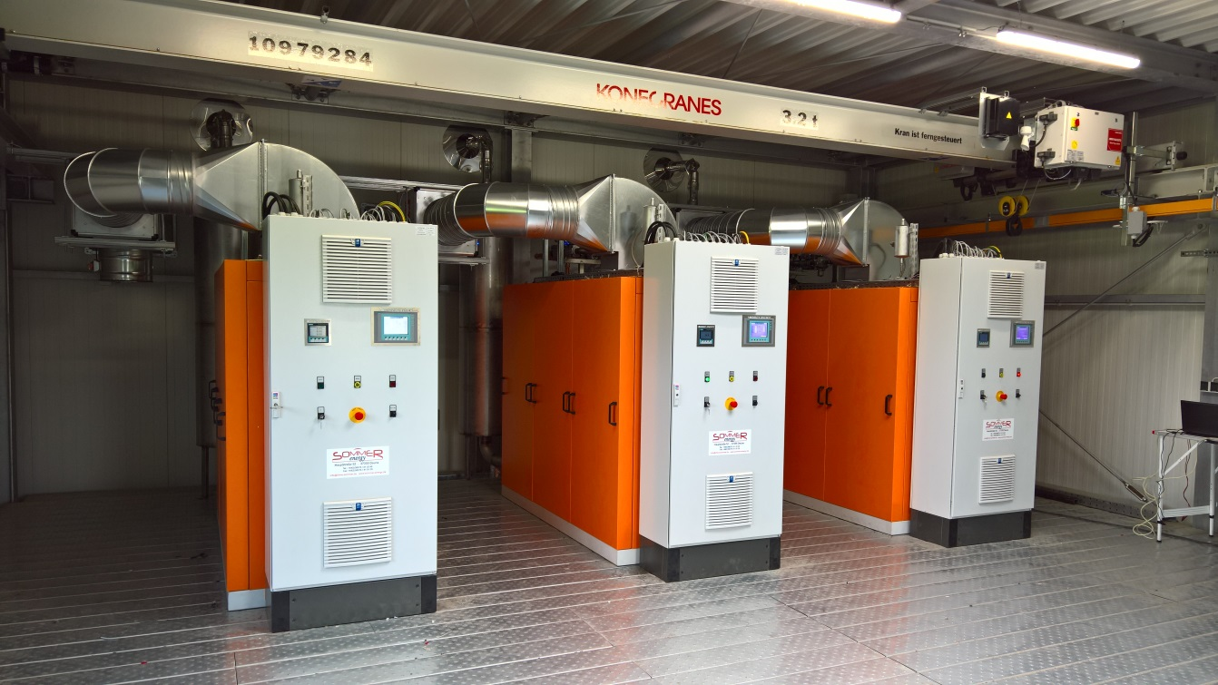

**Table of Contents**

[1. General safety instructions 3](#_Toc21355567)

[I. Explanation of symbols 3](#_Toc21355568)

[II. Glossary 3](#_Toc21355569)

[III. Safety instructions 4](#_Toc21355570)

[IV. Potential safety risks 5](#_Toc21355571)

[2. Product Description 10](#_Toc21355572)

[I. General information 10](#_Toc21355573)

[II. Module Design 10](#_Toc21355574)

[III. Module Data 11](#_Toc21355575)

[IV. Electrical connection 12](#_Toc21355576)

[3. Operation and control 13](#_Toc21355577)

[I. Before the first start 13](#_Toc21355578)

[II. Operator Panel 13](#_Toc21355579)

[III. Mains parallel operation 14](#_Toc21355580)

[IV. Trend curves 15](#_Toc21355581)

[V. Settings 15](#_Toc21355582)

[VI. Emergency stop function and stop 16](#_Toc21355583)

[VII. Error and diagnosis 17](#_Toc21355584)

[4. Remote maintenance 22](#_Toc21355585)

[5. Operation Additional modules 24](#_Toc21355586)

[I. Hot water storage tank 24](#_Toc21355587)

[II. Power output ramp 25](#_Toc21355588)

[III. Regulation - mixture cooler temperature 26](#_Toc21355589)

[IV. Control - return cooling (emergency cooling) 27](#_Toc21355590)

[V. Regulation Biogaspressure 28](#_Toc21355591)

[VI. Biogas Analysis 29](#_Toc21355592)

[VII. Communication of several SH plants 30](#_Toc21355593)

[VIII. Profibus communication 30](#_Toc21355594)

[IX. Modbus RTU Schnittstelle 33](#_Toc21355595)

[X. Modbus TCP interface 34](#_Toc21355596)

[6. Emergency function (optional) 35](#_Toc21355597)

[I. Basic Principle 35](#_Toc21355598)

[7. Maintenance Schedule 37](#_Toc21355599)

[8. Declaration of conformity 38](#_Toc21355600)

# General safety instructions

## Explanation of symbols

|  |  |
| --- | --- |
| C:\Users\APO\AppData\Local\Microsoft\Windows\Temporary Internet Files\Content.IE5\1FY2ANMF\685px-Achtung.svg[1].png | **Danger**  The symbol indicates operating instructions which can lead to injury or death. |
| C:\Users\APO\AppData\Local\Microsoft\Windows\Temporary Internet Files\Content.IE5\NIU01ZCA\Stop_hand.svg[1].png | **Warning**  This symbol indicates operating instructions which can lead to damage to the equipment. |
| C:\Users\APO\AppData\Local\Microsoft\Windows\Temporary Internet Files\Content.IE5\08AC0WS1\Information[1].png | **Information**  This symbol indicates important information about the handling of the entire system. |

## Glossary

***machine operator***

… are employees who are not specially trained, but can carry out simple tasks such as simple control tasks at the operator panel, check the status of the system and inform the technical customer service in the event of faults.

***qualified technician***

… are professionally trained workers who have received specific training courses in the areas of heating systems, heat generators, electrical engineering, electrical power generation systems, internal combustion engines. The qualification is obtained only directly from Sommer energy itself.

***maintenance staff***

… are persons who are trained and authorized by Sommer energy to maintain the facilities.

***Personal protective equipment (PPE)***

... includes the following equipment:

* Gehörschutz (Kapselgehörschützer, Bügelgehörschützer, Gehörschutzstöpsel o.ä.) bei Untersuchungen am laufenden Aggregat, welche von notwendig sein können
* Work gloves when working with batteries, glycol containing fluids or engine lubrication oils
* Protective shoes

|  |  |
| --- | --- |
| C:\Users\APO\AppData\Local\Microsoft\Windows\Temporary Internet Files\Content.IE5\NIU01ZCA\Stop_hand.svg[1].png | PPE ist während einer Wartung an der SH-Anlage immer zu tragen. |

***Energy supply companies (RUs)***

… represents the company responsible for the local energy supply. This company is the contact person for connecting the plant to the public utility network.

## Safety instructions

Safety instructions are used for occupational health and safety and accident prevention. You should always be respected. In order to protect you and your work colleagues from harm, your cooperation is also necessary. Always work with caution. Be constantly aware that dangers are not always "obvious".

This CHP is built for safe operation. However, responsibility lies with the persons who operate and maintain this CHP. The following safety precautions are guidelines to prevent the risk of accidents during operation.

The operating instructions and the safety instructions must be kept in a safe place for the operating personnel. The relevant accident prevention regulations and other, generally recognized safety and health rules and regulations of the respective country of use must be observed and followed.

The cogeneration unit may only be operated and maintained by trained and authorized persons who have read and understood these operating instructions. Failure to observe these instructions and safety precautions may result in burns, other injuries or killing by electricity and / or damage to the machine and other property of the customer.

|  |  |
| --- | --- |
| C:\Users\APO\AppData\Local\Microsoft\Windows\Temporary Internet Files\Content.IE5\1FY2ANMF\685px-Achtung.svg[1].png | **If the CHP is not in a safe condition:**   1. **Never start the CHP!** 2. **Press emergency stop button!** 3. **Attach the warning sign to the CHP!** 4. **Set the key switch on the control cabinet to "0" and remove it!** |

## Potential safety risks

|  |  |
| --- | --- |
| **Movable parts** | |
|  | * Keep hands, arms, and other parts of the body away from moving parts. * Wear close-fitting clothing and hearing protection when working on the CHP. * Wearing wristwatches, rings, chains or similar jewelery is not permitted. * Ensure that there are no personnel in the immediate vicinity of the CHP before starting. * Stop the engine before oil or coolant is filled. * Adjustments and maintenance must only be carried out with the motor stopped. * Keep hands, shoes, floor and other treads clean and free of oil, water, antifreeze and other fluids. |

|  |  |
| --- | --- |
| **Hot surfaces, sharp edges and corners** | |
| **C:\Users\APO\AppData\Local\Microsoft\Windows\Temporary Internet Files\Content.IE5\NIU01ZCA\DIN_4844-2_Warnung_vor_heisser_Oberflaeche_D-W026.svg[1].png** | **Protect yourself by wearing proper protective clothing!**   * Keep away from hot exhaust and exhaust pipes. * Wear protective clothing, gloves and head protection when working on the CHP. * Avoid skin contact with hot oil, coolant, surfaces and sharp edges and corners. * Provide a dressing box. In case of injuries, consult a doctor immediately.   ***For burns:***   * Immediately cool the injured parts with cold, clean water * Immediately give medical treatment to burns. |

|  |  |
| --- | --- |
| **Electric voltage / current** | |
| C:\Users\APO\AppData\Local\Microsoft\Windows\Temporary Internet Files\Content.IE5\08AC0WS1\616px-DIN_4844-2_Warnung_vor_gef_el_Spannung_D-W008.svg[1].png | * The CHP may only be connected to the load by trained and qualified electricians. * Keep in mind that no cables are pinched or squeezed and that they are laid so that they do not form any obstacles and can not be damaged. All cables, which are unprotected outside the machine / system, must be regularly checked for damage. * Do not touch any voltage-carrying parts of the cogeneration unit, connecting cables or cables. Pay attention to dry treads. * Before electrical connections to consumers are made or interrupted, ensure that the consumers and the CHP are connected to the protective measures of the electrical power grid. * Before switching on electrical connections at the CHP, the CHP must be switched off. * The cogeneration unit must not be operated without covers on voltage-carrying parts. * Provide suitable fire extinguishers approved for electrical installations. * Only connect the CHP to loads and electronic systems that are compatible with the specification and are within the rated power. |
| **Damage caused by electricity can have the following effects:**   * Muscle contraction, as long as the electrical action persists * At the current entry and exit points, so-called "current marks" occur during the current flow, possibly also fire wounds * including unconsciousness, breathing space * Danger of life by circulatory system   **Measures:**   * Interruption of the power supply by disconnection, disconnect the plug, disconnect the fuses, switch off the main switch * If this is not immediately possible, the person who is injured is disconnected from the live parts by a non-conducting object * Stand up in isolation and do not touch voltage-carrying parts * Establish immediate rest position * Check breathing and pulse: * in the case of respiratory distress: respiratory donor * in case of unconsciousness and breathing: stable lateral position * Cover burns without germs * Call the emergency | |

|  |  |
| --- | --- |
| C:\Users\APO\AppData\Local\Microsoft\Windows\Temporary Internet Files\Content.IE5\1FY2ANMF\685px-Achtung.svg[1].png | **In emergency situations of any kind, the CHP is to be put out of operation immediately.**  **For this purpose, either the main switch or, where available, the EMERGENCY STOP switch, or other known safety devices which serve to shut down the machine / system press.** |

|  |
| --- |
| **Danger of confinement** |
| If work is carried out at the CHP, it must be ensured that the access doors can not be closed by other persons. |

|  |
| --- |
| **Maintenance of the cogeneration plant** |
| The maintenance of the CHP unit is to be carried out only by authorized maintenance personnel. The maintenance instructions and instructions are available to the maintenance personnel. |

|  |  |
| --- | --- |
| C:\Users\APO\AppData\Local\Microsoft\Windows\Temporary Internet Files\Content.IE5\1FY2ANMF\685px-Achtung.svg[1].png | **If you smell gas:**   * Close the gas shut-off valve * Ventilate the room * Avoid the use of electrical appliances, mobile phones included * Leave the room and notify a qualified technician or a person of the responsible gas supplier. If neither the technician nor the responsible person of the gas supplier is reachable and is a distress, call the fire brigade * If the road is equipped with leakage monitoring, and if this is disturbed, the technician must be informed |

|  |  |
| --- | --- |
| C:\Users\APO\AppData\Local\Microsoft\Windows\Temporary Internet Files\Content.IE5\1FY2ANMF\685px-Achtung.svg[1].png | **In case of burned smell:**   * Switch off the system * Ventilate the room * Notify a qualified technician * If the room is equipped with a smoke detector and / or a gas alarm, report any malfunction to the technician |
| C:\Users\APO\AppData\Local\Microsoft\Windows\Temporary Internet Files\Content.IE5\1FY2ANMF\685px-Achtung.svg[1].png | **For liquid leaks:**   * Switch off the system * Notify a qualified technician * Lock both the gas and the external water supply via the valves |
| C:\Users\APO\AppData\Local\Microsoft\Windows\Temporary Internet Files\Content.IE5\NIU01ZCA\Stop_hand.svg[1].png | The installation, calibration and adjustment of the gas supply system, the electrical installation and the water pipe system may only be carried out by qualified technicians in accordance with the applicable national and regional standards and regulations. |
| C:\Users\APO\AppData\Local\Microsoft\Windows\Temporary Internet Files\Content.IE5\1FY2ANMF\685px-Achtung.svg[1].png | Before commissioning the system, the exhaust system must be checked for leaks and approved by local authorities. |
| C:\Users\APO\AppData\Local\Microsoft\Windows\Temporary Internet Files\Content.IE5\08AC0WS1\Information[1].png | The operator is advised to keep his system in a good condition in order to keep plant availability high and to not endanger the safety of all employees. |
| C:\Users\APO\AppData\Local\Microsoft\Windows\Temporary Internet Files\Content.IE5\08AC0WS1\Information[1].png | The operator has to ensure that only qualified technicians maintain and maintain the system according to the maintenance schedule. |
| C:\Users\APO\AppData\Local\Microsoft\Windows\Temporary Internet Files\Content.IE5\1FY2ANMF\685px-Achtung.svg[1].png | Before the first start, all connections must be checked and checked for tightness and, if necessary, retightened. |
| C:\Users\APO\AppData\Local\Microsoft\Windows\Temporary Internet Files\Content.IE5\08AC0WS1\Information[1].png | This manual is an important part of the system and should be accessible to all operators, technicians and other persons involved in the installation. Should the system change its owner / location, it is strongly recommended to hand over this manual. |

# Product Description

## General information

A combined heat and power plant (CHP) is a modular system for generating electricity and heat.

The higher overall utilization ratio compared to the conventional combination of local heating and central power plant results from the utilization of the waste heat of the electricity generation directly at the place of origin. Depending on the plant size, the efficiency of the electricity generation is between about 30 and 40%. However, the local primary use of the waste heat is 75 to over 90%. Combined heat and power plants can save up to 40% of primary energy.

Originally, CHP plants are based on combustion engines whose heat from the exhaust gas and the cooling water circuit is used to heat heating water. In the meantime, other systems such as the Stirling engine, fuel cell, microturbine or steam engine are also used to generate electricity in CHP plants. Depending on the type of internal combustion engine, the use of combined heat and power plants is not limited to providing room heat, but also serves to generate process heat via water vapor, hot air or thermal oil or air-conditioning by use of an absorption heat pump.

## Module Design

The motor and the generator are rigidly flanged and connected by a flexible coupling.

This unit is stored on a vibration absorbing base. To avoid sound transmission by vibration, the connection to the heating is via compensators. Furthermore, the basic frame is placed on Sylomers. Thus, no vibrations are transmitted to the building.

The heat exchanger block is installed in front of and below the engine base unit. The cooling water heat and the exhaust gas heat are extracted via heat exchangers and delivered to the heating system.

For sound insulation, the unit can be supplied with a sound-proof capsule, the supply and exhaust air is supplied and removed via fans, including air mufflers.

The electrical monitoring and control units as well as the power section are housed in a control cabinet.

## Module Data

|  |  |
| --- | --- |
| **Continuous power of the unit** | |
| Rated electrical power parallel to the mains @ cosPhi = 1.0 | 100 kW |
| Thermal performance | 129 kW |
| Voltage | 400 V |
| Motor water temperature max | 88 °C |
| Exhaust gas temperature after heat exchanger | 120 °C |
| Heating forflow max. | 90 °C |
| Heating return max. | 70 °C |
| CHP Dimensions (L x W x H) | 6,0m x 2,5m x 2,95 m |

|  |  |
| --- | --- |
| **Technical data of the engine** | |
| Manufacture | MAN |
| Continuous power mech. (ISO 3046) | 110 |
| number of cylinders | 6 |
| Rated speed | 1500 RPM |
| Drilling | 108 mm |
| Stroke | 125 mm |
| Capacity | 6,87 l |

|  |  |
| --- | --- |
| **Technical data of the generator** | |
| Manufacture | Leroy Somer |
| Type | LSA 44.3 L10 |
| Power | 137 kVA |
| Rated speed | 1500 RPM |
| Voltage | 400 V |
| Frequenzy | 50 Hz |
| Cooling | Self cooled |
| cos Φ | 1.0 |
| Altitude | ≤ 1000 m above sea level |

## Electrical connection

For mains parallel operation, the connection to the switchgear is to be made, to check the rotating field for clockwise rotation, to lay out the cross section to a permanent electrical rated load and to connect it to the connections provided for this purpose.

There are different connection possibilities:

1. Connection to terminals and the circuit breaker
2. Connection to terminals
3. onnection to circuit breaker and busbar
4. Project-specific variant

As a rule, the connection is located at the bottom left of the switchgear. For project-specific connections, the connection with the manufacturer must be clarified in advance.

# Operation and control

## Before the first start

All sensors must be checked for plausibility. All limit values are set at the factory. Before the first start, the circuits are tested.

## Operator Panel

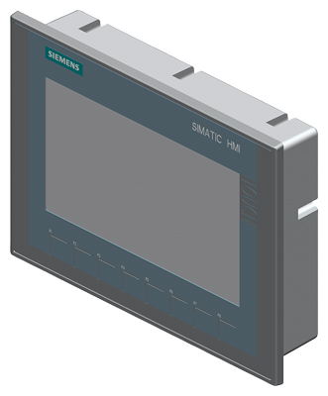

Figure 1 - KTP 700 as standard display [[1]](#footnote-1)

|  |  |
| --- | --- |
| **General information** | |
| Product type designation | SIMATIC HMI KTP700 Basic color PN |
| *Display* | |
| Design of the display | TFT |
| screen size | 7,0 in |
| display width | 154,1 mm |
| display height | 85,9 mm |
| number of colors | 65 536 |
| *Resolution (pixels)* | |
| ● horizontal image resolution | 800 Pixel |
| ● vertical image resolution | 480 Pixel |

## Mains parallel operation

In order to implement the parallel system, the motor is started and then controlled to the nominal speed. The generator is connected in parallel with the mains by means of the synchronizer. The voltage, frequency and the delay time of the switching element are taken into account in order to ensure a "gentle" engagement. After a short gas-air mixture settling time, a stepless regulation between PN and 50% of PN is possible.

|  |  |
| --- | --- |
| **Mode selection switch** | |
| ***Hand*** | The manual mode starts the unit without the specific starting conditions such as a low return temperature have to be met. The possible alarm / warning messages are acknowledged via the interference button.  In this mode, the operator is required to manually power the mains supply and prevent the entire system from being disturbed. Possible foreseeable switch-off conditions are not considered. |
| ***Auto*** | In the automatic mode, the controller decides whether the system starts or not. Only when all start conditions are met, the system is started.  In this case, the operator is only required in the event of a fault. However, it is responsible for the settings that can be set for the operator via the HMI.  By using a modular controller, project- / customer-specific signals can be transferred and integrated into the logic of the control system. Experience has shown that the following signals can be added with:   * External start / stop signal * Performance specification as analogue value request * Power requirements of the RU |

## Trend curves

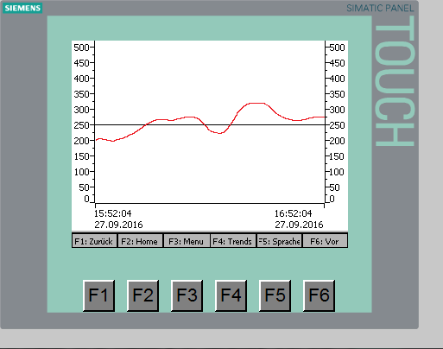 Standard motor, energy, temperature and pressure data are available as a trend curve.

Figure 2 - Example of a performance curve

The data is cyclically recorded in a non-retentive memory and displayed. For storage reasons, only the past hour can be considered.

Trend curves generally serve to gain information and help diagnose errors or identify imprecise deficits at an early stage. They are therefore an important tool for machine operators and technicians.

## Settings

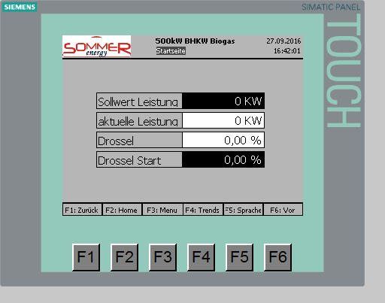 Basically, setting values on black fields can be recognized with white characters.

By pressing the finger on the corresponding field, an input mask opens.

Figure 3 - Beispiel Eingabefelder

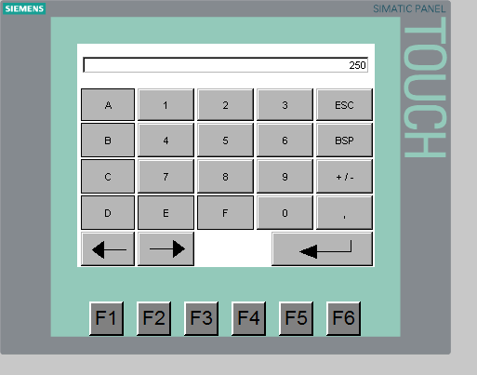 Depending on the declaration of the field, you can now enter numbers and letters or only numbers. This prevents the wrong data formats from being entered. The limit values of the input are rechecked by the controller itself and corrected to the intended range if necessary.

In Figure 4 - you see such a number entry in the input field already described.

Figure 4 - Example input screen with numbers

## Emergency stop function and stop

Figure 5- Emergency stop function and stop

The fail-safe power failure protection device (mains failure protection) and the installed safety switch provide the highest protection for man and machine.

With the safety switch, we reach a safety integrity level (SIL) according to IEC 62061 of SIL 1 and thus comply with the machinery guideline of 2006. After this, it is also necessary that a manual reset is necessary after triggering the emergency stop chain. The green operating button is used for this purpose. The switching device recognizes a long acknowledgment as well as a short acknowledgment and responds accordingly not to the inputs.

Upon detection of the emergency deactivation, switch off the ignition, gas valves and the generator switch as shown in Figure 5- Emergency stop function and stop . All components are selected in such a way that when there is no voltage, there is no danger for man or machine.

|  |  |
| --- | --- |
| C:\Users\APO\AppData\Local\Microsoft\Windows\Temporary Internet Files\Content.IE5\08AC0WS1\Information[1].png | It should be pointed out that when the machine rotates and the emergency stop function is triggered, the machine still runs out for a few seconds.  An active brake is not installed! |

## Error and diagnosis

|  |  |  |  |  |
| --- | --- | --- | --- | --- |
| ID | Alarm text | Class | Reason | Elimination |
| 1 | ALARM: EMERGENCY STOP | error | * Emergency chain interrupted (upper LED on K100 does not light up) * Missing acknowledgment (lower LED on K100 does not light up) | * Unlock all emergency stop switches * Push the green Button on the Front door |
| 3 | ALARM: OIL PRESSURE START | error | * Oil pressure switch defective | * Check the oil pressure switch |
| 4 | ALARM: MOTOR PROTECTION SWITCH | error | * Motor protection switch tripped | * Check the motor branches and eliminate the fault |
| 5 | ALARM: EVU INTERFERENCE | error | * Fault in the power supply network | * a stable power supply is disconnected for more than 2 min |
| 6 | ALARM: OVER TEMP. STARTER TRANSFORMER | error | * thermocontact on the mains power system | * Check the starter transformer and eliminate the fault |
| 7 | ALARM: OVER TEMP. MOTOR (95 ° C) | error | * Air in the heating system Circulation pump (internal pump) defective | * Check the circulating pump |
| 8 | ALARM: OVER TEMP. OIL (98 ° C) | error | * Faults in the lubrication system too little motor oil | * Check oil level |
| 9 | ALARM: OIL PRESSURE TOO LOW | error | * too little motor oil | * Check oil level |
| 10 | ALARM: OILSTAND MINIMUM | error | * Oil reservoir empty Defective oil level control contact | * Check for leaks |
| 11 | ALARM: OIL TANK | error | * Water or oil leaks | * Check the tightness |
| 12 | ALARM: GAS PRINT MINIMUM | error | * Gas supply failed | * Check the stopcocks on the opening |
| 13 | ALARM: CAPSULE TEMP. MAX | error | * Temperature in the sound insulation hood too high | * Check the capsule fan |
| 14 | WARNING: TROUBLESHOOTING. EXHAUST | error | * Exhaust gas temperature warning reached | * Motor reduces its power automatically |
| 15 | ALARM: TEMP.MAX EXHAUST | error | * Exhaust gas temperature too high | * Check air filter, spark plugs |
| 16 | ALARM: OVERRIDE | error | * Motor speed above 115% of nominal speed | * Restart the CHP with other start parameters |
| 17 | ALARM: WATER PRESSURE MIN | error | * Leakage in the cooling system | * Check the cooling system |
| 18 | ALARM: REVERSE POWER | error | * EVU grid drives generator | * Restart with higher Lambda Mixture at Synchpoint |
| 19 | ALARM: PERFORMANCE DIFFERENCE | error | * Setpoint and actual value deviate too much | * Check the lambda setting |
| 20 | ALARM: OVER TEMP. MIXTURE | error | * no mixture cooling | * Check the mixture cooling system |
| 21 | ALARM: SPEED DIFFERENCE | error | * Faulty ignition * Outdated lambda deer * Ignition strip defective | * Check ignition distance |
| 22 | ALARM: LAMBDA DIFFERENCE | error | * Lambda control defective / at control limits | * Check the lambda setting |
| 23 | ALARM: COS PHI DIFFERENCE | error | * CosPhi controller defective | * Check wiring for the CosPhi controller |
| 24 | ALARM: REFILL OIL | error | * Oil reservoir empty | * Add oil to the container |
| 25 | ALARM: SYNCHRONIZATION | error | * No mains connection within 7 min | * Check Generators Circuit breaker * Restart |
| 26 | ALARM: START SPEED (STARTER) | error | * Starter has been set but engine does not rotate | * Check the speed sensor |
| 27 | ALARM:> 3 STARTS | error | * CHP has not started | * Check the starting settings |
| 28 | WARNING: MAINTENANCE REQUIRED | warning | * the maintenance period has expired in the next 50 operating hours | * Notify maintenance service |
| 29 | ALARM: MAINTENANCE TIME EXCEEDED | error | * Maintenance time has expired | * Carry out maintenance work (let) |
| 30 | ALARM: OVER TEMP. HEATING PROCEDURE | error | * Heating over 98 ° C | * Check the circulating pump externally and the water pressure |
| 31 | ALARM: SMOKE DETECTED | error | * Smoke gas detected | * Locate and eliminate smoke |
| 32 | ALARM: GAS OVER LIFT (40%) | error | * Gas warning system has detected gas | * Locate and eliminate the gas |
| 33 | ALARM: FU 1 EXTERNAL PUMP | error | * Pending error in the frequency converter for the external pump | * Observe the display of the drive and correct the diagnosis via the error list of the drive |
| 34 | ALARM: FU 2 MIXED COOLER FAN 1 | error | * Incident on the frequency converter | * Observe the display of the drive and correct the diagnosis via the error list of the drive |
| 35 | ALARM: FU 3 MIXED COOLER FAN 2 | error | * Incident on the frequency converter | * Observe the display of the drive and correct the diagnosis via the error list of the drive |
| 36 | ALARM: FU 4 MIXED COOLER FAN 3 | error | * Incident on the frequency converter | * Observe the display of the drive and correct the diagnosis via the error list of the drive |
| 37 | ALARM: FU 5 OTHERS | error | * Incident on the frequency converter | * Observe the display of the drive and correct the diagnosis via the error list of the drive |
| 38 | ALARM: HEATING RETURN TO WARM | error | * Cooling water for control outside the permissible temperature range | * Observe the limit values |
| 39 | ALARM: PRESSURE WATER EXTERNAL | error | * Leakage at the external circuit | * Observe the limit values |
| 40 | ALARM: Biogas temperature | error | * Temperature of the fuel biogas too high | * Observe the limit values |
| 41 | ALARM: Pressure mixture | error | * leakage at the mixture cooling circuit | * Observe the limit values |
| 42 | ALARM: Pressure Biogas Analog | error | * Absence of gas pressure measured analogously | * Observe the limit values |
| 43 | ALARM: ERROR AVR GENERATOR | error | * General fault of the voltage regulator | * Check the regulator |
| 46 | ALARM: COMMUNICATION PARTNER 1 | error | * Lost connection to partner | * Check the connection cable |
| 47 | ALARM: COMMUNICATION PARTNERS 2 | error | * Lost connection to partner | * Check the connection cable |
| 48 | ALARM: COMMUNICATION PARTNER 3 | error | * Lost connection to partner | * Check the connection cable |
| 49 | ALARM: COMMUNICATIONSPARTNER 4 | error | * Lost connection to partner | * Check the connection cable |
| 50 | ALARM: COMMUNICATION PARTNER 5 | error | * Lost connection to partner | * Check the connection cable |
| 51 | ALARM: COMMUNICATIONSPARTNER 6 | error | * Lost connection to partner | * Check the connection cable |
| 52 | ALARM: COMMUNICATION PARTNERS 7 | error | * Lost connection to partner | * Check the connection cable |
| 65 | SENSOR ERROR: TEMPERTUR MOTOR INPUT | error | * Sensor defective outside the display range Cable breakage | * Check encoder if necessary |
| 66 | SENSOR ERROR: TEMPERATURE MOTOR OUTPUT | error | * Sensor defective outside the display range Cable breakage | * Check encoder if necessary |
| 67 | SENSOR ERROR: TEMPERTURE CAPSULE | error | * Sensor defective outside the display range Cable breakage | * Check encoder if necessary |
| 68 | SENSOR ERROR: TEMPERATURE MIXTURE | error | * Sensor defective outside the display range Cable breakage | * Check encoder if necessary |
| 69 | SENSOR ERROR: TEMPERATURE HEATING PROCEDURE | error | * Sensor defective outside the display range Cable breakage | * Check encoder if necessary |
| 70 | SENSOR ERROR: TEMPERATURE HEATING RETURN | error | * Sensor defective outside the display range Cable breakage | * Check encoder if necessary |
| 71 | SENSOR ERROR: TEMPERATURE BUFFER 1 | error | * Sensor defective outside the display range Cable breakage | * Check encoder if necessary |
| 72 | SENSOR ERROR: TEMPERATURE BUFFER 2 | error | * Sensor defective outside the display range Cable breakage | * Check encoder if necessary |
| 73 | SENSOR ERROR: TEMPERATURE BUFFER 3 | error | * Sensor defective outside the display range Cable breakage | * Check encoder if necessary |
| 74 | SENSOR ERROR: TEMPERATURE BUFFER 4 | error | * Sensor defective outside the display range Cable breakage | * Check encoder if necessary |
| 75 | SENSOR ERROR: TEMPERATURE BUFFER 5 | error | * Sensor defective outside the display range Cable breakage | * Check encoder if necessary |
| 76 | SENSOR ERROR: TEMPERTURAL GAS A | error | * Sensor defective outside the display range Cable breakage | * Check encoder if necessary |
| 77 | SENSOR ERROR: TEMPERATURE EXHAUST B | error | * Sensor defective outside the display range Cable breakage | * Check encoder if necessary |
| 78 | SENSOR ERROR: OIL PRESSURE | error | * Sensor defective outside the display range Cable breakage | * Check encoder if necessary |
| 79 | SENSOR ERROR: WATER PRESSURE | error | * Sensor defective outside the display range Cable breakage | * Check encoder if necessary |
| 80 | SENSOR ERROR: LAMBDA A | error | * Sensor defective outside the display range Cable breakage | * Check encoder if necessary |
| 81 | SENSOR ERROR: LAMBDA B | error | * Sensor defective outside the display range Cable breakage | * Check encoder if necessary |
| 102 | WARNING: TEMPERATURE MOTOR INPUT | warning | * Pre-warning the temperature outside the permissible range | * Check plausibility of encoder if necessary |
| 103 | WARNING: TEMPERATURE MOTOR OUTPUT | warning | * Pre-warning the temperature outside the permissible range | * Check plausibility of encoder if necessary |
| 104 | WARNING: TEMPERATURE CAPSULE | warning | * Pre-warning the temperature outside the permissible range | * Check plausibility of encoder if necessary |
| 105 | WARNING: TEMPERATURE HEATING VL | warning | * Pre-warning the temperature outside the permissible range | * Check plausibility of encoder if necessary |
| 106 | WARNING: TEMPERATURE HEATING RL | warning | * Pre-warning the temperature outside the permissible range | * Check plausibility of encoder if necessary |
| 107 | WARNING: TEMPERATURE MIXTURE | warning | * Pre-warning the temperature outside the permissible range | * Check plausibility of encoder if necessary |
| 108 | WARNING: TEMPERATURE OF GAS A | warning | * Pre-warning the temperature outside the permissible range | * Check plausibility of encoder if necessary |
| 109 | WARNING: TEMPERATURE EXHAUST B | warning | * Pre-warning the temperature outside the permissible range | * Check plausibility of encoder if necessary |
| 110 | WARNING: PRESSURE OIL | warning | * Pre-warning of pressure outside the permissible range | * Check plausibility of encoder if necessary |
| 111 | WARNING: INTERNAL PRESSURE WATER | warning | * Pre-warning of pressure outside the permissible range | * Check plausibility of encoder if necessary |
| 112 | WARNING: PRESSURE WATER EXTERNAL | warning | * Pre-warning of pressure outside the permissible range | * Check plausibility of encoder if necessary |
| 113 | WARNING: PRESSURE MIXTURE | warning | * Pre-warning of pressure outside the permissible range | * Check plausibility of encoder if necessary |
| 114 | WARNING: Temperature biogas | warning | * Pre-warning the temperature outside the permissible range | * Check plausibility of encoder if necessary |
| 115 | WARNING: PRESSURE BIOGAS | warning | * Pre-warning of pressure outside the permissible range | * Check plausibility of encoder if necessary |
| 116 | WARNING: FILL OIL | warning | * Pre-warning oil level low | * Check plausibility of encoder if necessary |
| 117 | WARNING: Gas | warning | * Gas warning system has detected gas and gives warning | * Locate and remove the gas outlet Ventilate the room well Immediately stop in doubt machine |

# Remote maintenance

Remote maintenance for the system is made via a PC installed in the control cabinet. This is equipped with the necessary hardware and software for monitoring and controlling the entire system. The system can also be operated without remote maintenance. If interference occurs in remote maintenance, the module can also be removed for diagnostic purposes without disturbing the system.

If prolonged access to the system is not initiated, the PC automatically protects itself with logout from the Windows. To reactivate, the user name ***Viewer*** with the password ***bhkw*** is necessary.

This interface can vary from plant to plant and allows access to several plants in the entire plant.

A prerequisite for access is a DSL line which must be created by the customer. There are also substitute solutions which are then dependent on the respective location and have to be clarified project-specifically prior to connection.

The internal network is separated from the hardwares for reasons of communication in order to eliminate error communications.

The connection is made via TeamViewer to the system. The connection data are to be requested from the manufacturer after the connection test has been carried out. Other third party remoteconnections must declared with the manufacturer.

***Example of remote monitoring***

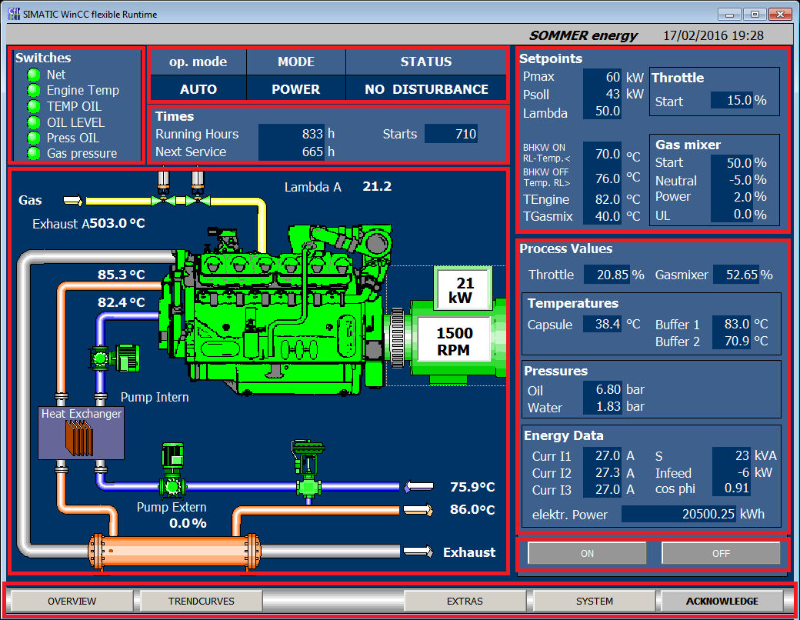

5

8

4

7

6

3

1

2

|  |  |
| --- | --- |
| Area | Description |
| 1 | Brief overview of the switching states of the encoders |
| 2 | Switch states of the preselector switches on the control cabinet |
| 3 | Overview of the times of the CHP |
| 4 | Plant view with the most important analog data at the installation location |
| 5 | Menu for other areas / plants  Call up extra functions such as emergency cooling, etc. from chapter 5  Call up the error history  Acknowledgment of a corrected error |
| 6 | Adjustable values for controlling the CHP |
| 7 | Overview of the analog actual values |
| 8 | Power on / off via the PC-HMI |

# Operation Additional modules

## C:\Users\APO\Desktop\Netzwerktausch\Manual\Pufferspeicher.png Hot water storage tank

Figure 6 - Sample buffering solution

In the ideal case, the CHP is designed in such a way that a continuous operation of the unit takes place. However, it is rare that the full heat energy can be used over the entire period. Therefore, buffer storage solutions are used. Thus, it is not only possible to intercept peak loads, but also to pass through demand valleys without stopping the aggregate. Therefore, particularly effective in connection with the module of the Power output ramp.

The heating system must be designed in the open or low pressure system, since the cooling water is supplied with a pump for use in the low pressure system. On request, it is possible to use it in a closed or pressurized heating systems.

The starting and stopping of the unit is provided by means of the buffer connection and the plausibility of the storage sensors.

As a rule, a discharge pump is also provided for the removal of the heat energy and can be controlled with it. The on / off point is adjustable and can be changed by the operator.

## Power output ramp

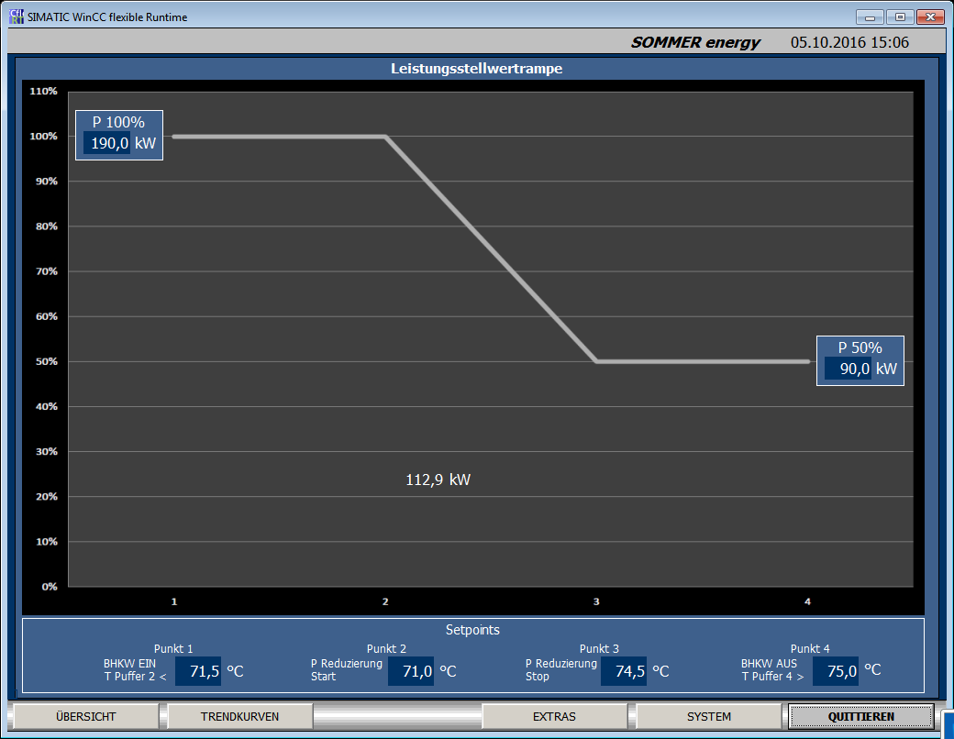

Figure 7 - Beispiel HMI Leistungsstellwertrampe

The option of the power setting value ramp allows operators to easily decide with which return temperature the analog setpoint control should start. This provides the option of not only switching off and restarting CHPs but also automatically switching them down before power down in order to prevent them from switching off and thus preventing them from standing still.

If the ramp is set correctly and the return temperatures at the CHP start falling again, the system automatically increases its setpoint again to the set maximum capacity.

The curve can be adapted by the operator and edited at any time. An analogue control between 100% and 50% of the maximum power is permissible. Incorrect input parameters are automatically corrected.

## Regulation - mixture cooler temperature

Figure 8 – Example two-stage mixture cooling

It must be differentiated between single-stage and two-stage mixture cooling.

In single-stage mixture cooling, there is only one HT circuit. The pump to be controlled is designed in such a way that a mixture temperature of 80 ° C. is reached in full load operation.

The two-stage, on the other hand, is more complex. The NT circuit is fed by a preceding pump. In the HT-circuit it, then the active control of the mixture to 50 ° C over the prepared mixture table radiator fan. This circuit is equipped with a pressure transducer as well as an expansion vessel and an overpressure valve. Since the range of the mixture cooler fan is installed in the open air, a maximum of 30% glycol is used as medium for heat transfer in order to prevent freezing when not in use. The mixture cooling fans are frequency-controlled. In special conduits, the pump can also be frequency-regulated to compensate for poor control behavior.

If there are faults on the mixture cooling circuit, they are displayed as a clear text in the display. The control is firmly programmed and tested during commissioning.

## Control - return cooling (emergency cooling)

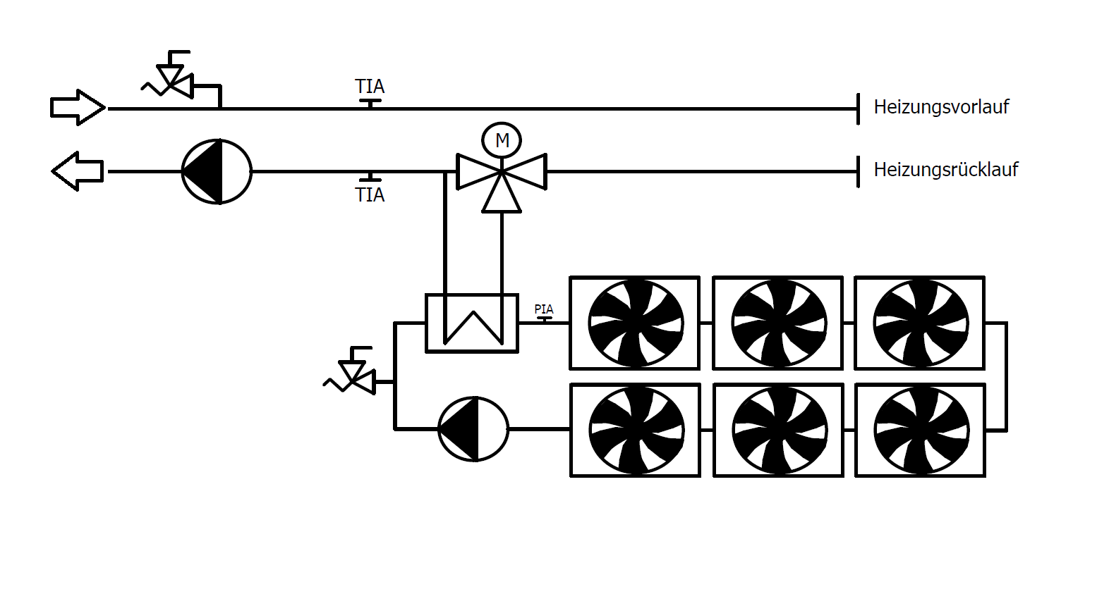

Figure 9 – Reflux condenser

The so-called return or emergency cooler provides the possibility to react actively to the return from the heating. Equipped with a black-white valve, a plate heat exchanger, emergency cooling can be activated from the control.

The control electronics react to the return with a continuous PI controller and can usually switch up to 6 stages for active cooling. This version is also available on request.

The sensitive table cooler is equipped with protective equipment and is permanently monitored.

## Regulation Biogaspressure

**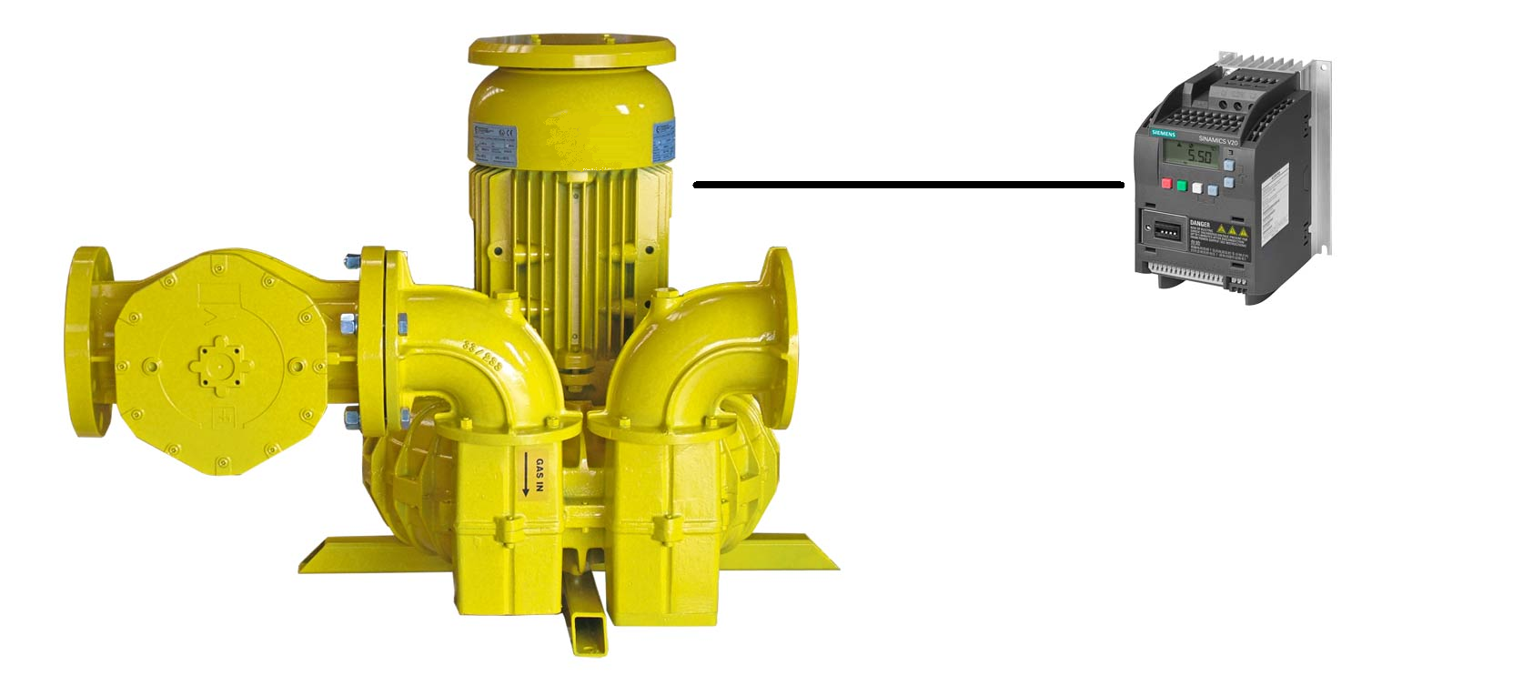**

Figure 10 - frequency controlled compressor

Basically, the side-channel compressors are designed to control unregulated motors rotating at the rated frequency and to transport air or gases to higher pressure stages.

The operator can determine at which speed the compressor is to be operated for starting. This is crucial in order to make the best use of the preset zero pressure. The operator is thus able to react to possible pressure fluctuations in the system and to increase or decrease the pre-pressure.

If the cogeneration unit is started and the power is output, the control is set to an adjustable pressure. This not only protects the compressor by minimizing the wear caused by the rotational speed, but the compressor can now counteract pressure fluctuations in the network and ensure an optimum gas supply to the CHP.

## Biogas Analysis

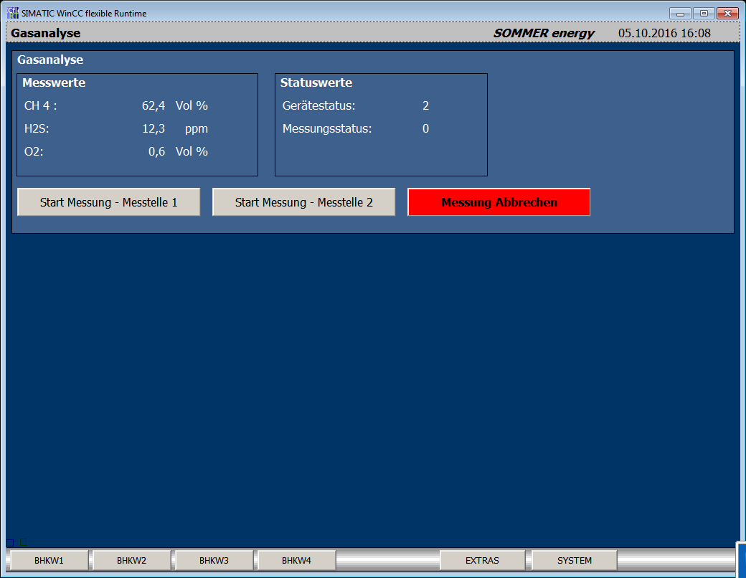

Figure 11 – Biogas analysis

The extension of the control to Profibus is necessary to connect the biogas analysis. The data are exchanged under the control and the analyzer via a DP-V0 communication.

The values are displayed and can be archived as required.

In addition to the possibility of regular time-controlled remeasurement at the analyzer itself, the operator can also initiate or abort a measurement via the HMI.

Based on the status values, the operator can interpret the state of the analyzer. Please also refer to the operating instructions for the analyzer.

## Communication of several SH plants

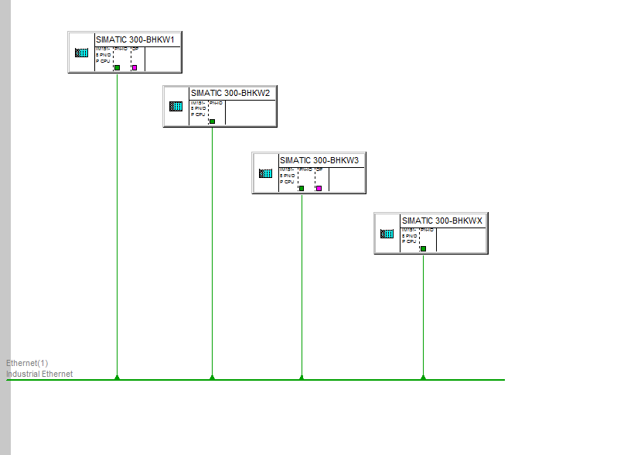

Figure 12 - Profinetcommunication

If several modules are operated together as an overall system, it is advisable to create a link between them. This offers advantages in the regulation, the use of data and in the control of actuators in the different individual units.

Through the type of communication, signals can be distributed and the hardware effort can be reduced to a minimum. If the communication fails, the switches should be controlled in the network level. Network diagnostics may also be necessary.

## Profibus communication

Third-party systems can be connected to the controller either directly or via a DP-DP coupler. The individual data points must be matched beforehand and a function test must take place.

The following is an example of such a communication:

Appendix: CHP 500 kW Example

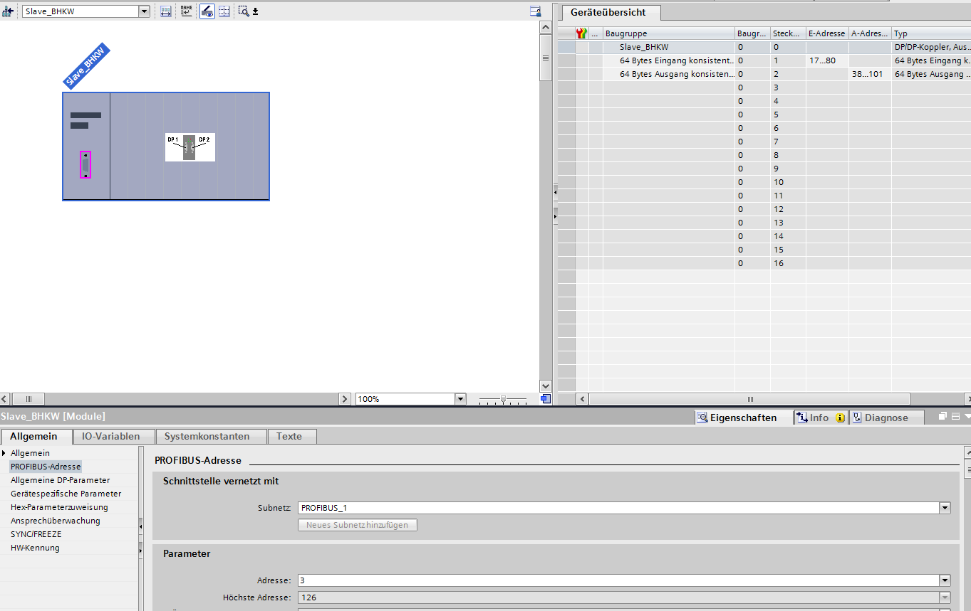

Figure 13- Hardware overview

Interface overview:

|  |  |  |  |  |
| --- | --- | --- | --- | --- |
| Input | | | | |
| 64 Bytes consistent | Value | Formate | Accuracy | Unit |
| DWord 0 | SP\_P\_EXTERNAL | Real | 1 | kW |
| DWord 4 | Reserve | Real |  |  |
| DWord 8 | Reserve | Real |  |  |
| DWord 12 | Reserve | Real |  |  |
| DWord 16 | Reserve | Real |  |  |
| DWord 20 | Reserve | Real |  |  |
| DWord 24 | Reserve | Real |  |  |
| DWord 28 | Reserve | Real |  |  |
| DWord 32 | Reserve | Real |  |  |
| DWord 36 | Reserve | Real |  |  |
| DWord 40 | Reserve | Real |  |  |
| DWord 44 | Reserve | Real |  |  |
| DWord 48 | Reserve | Real |  |  |
| DWord 52 | Reserve | Real |  |  |
| DWord 56 | Reserve | Real |  |  |
| DWord 60 | Reserve | Real |  |  |
| DWord 64 | Reserve | Real |  |  |

|  |  |  |  |  |
| --- | --- | --- | --- | --- |
| Output | | | | |
| 64 Bytes consistent | Value | Formate | Accuracy | Unit |
| DWord 0 | generated electric power | Real | 0,00 | kWh |
| DWord 4 | operating hours | Int | 1 | Oph |
| DWord 8 | gas consumption | Real | 0,1 | m³/h |
| DWord 12 | current performance | Real | 0,1 | kW |
| DWord 16 | generated heat quantity | Real | 0,0 | kWh |
| Word 20 | reports |  |  |  |
| Bit 0 | operation | Bool |  |  |
| Bit 1 | disorder | Bool |  |  |
| Bit 2 | Reserve | Bool |  |  |
| Bit 3 | Reserve | Bool |  |  |
| Bit 4 | Reserve | Bool |  |  |
| Bit 5 | Reserve | Bool |  |  |
| Bit 6 | Reserve | Bool |  |  |
| Bit 7 | Reserve | Bool |  |  |
| Bit 8 | Reserve | Bool |  |  |
| Bit 9 | Reserve | Bool |  |  |
| Bit 10 | Reserve | Bool |  |  |
| Bit 11 | Reserve | Bool |  |  |
| Bit 12 | Reserve | Bool |  |  |
| Bit 13 | Reserve | Bool |  |  |
| Bit 14 | Reserve | Bool |  |  |
| Bit 15 | Reserve | Bool |  |  |
| Bit 16 | Reserve | Bool |  |  |
| DWord 22 | Reserve |  |  |  |
| DWord 26 | Reserve |  |  |  |
| DWord 30 | Reserve |  |  |  |
| DWord 34 | Reserve |  |  |  |
| DWord 38 | Reserve |  |  |  |
| DWord 42 | Reserve |  |  |  |
| DWord 46 | Reserve |  |  |  |
| DWord 50 | Reserve |  |  |  |
| DWord 54 | Reserve |  |  |  |
| DWord 58 | Reserve |  |  |  |
| Word 62 | Reserve |  |  |  |
| Byte 64 | Reserve |  |  |  |

## Modbus RTU Schnittstelle

|  |  |  |
| --- | --- | --- |
| 16 Bit Register Nr. | Description | |
| 0 | **Reports** | |
|  | 0.0 | Hand operated |
|  | 0.1 | Generator on the mains (operation) |
|  | 0.2 | internal pump |
|  | 0.3 | external pump |
|  | 0.4 | Gas solenoid valve 1 open |
|  | 0.5 | Gas solenoid valve 2 open |
|  | 0.6 | Capsule fan |
|  | 0.7 | Reserve |
|  | 0.8 | Reserve |
|  | 0.9 | Reserve |
|  | 0.10 | Reserve |
|  | 0.11 | Reserve |
|  | 0.12 | Reserve |
|  | 0.13 | Reserve |
|  | 0.14 | Reserve |
|  | 0.15 | Reserve |
| 1 | **Alarms** | |
|  | 1.0 | Emergency stop switch |
|  | 1.1 | collective fault |
|  | 1.2 | Warning Maintenance |
|  | 1.3 | Reserve |
|  | 1.4 | Reserve |
|  | 1.5 | Reserve |
|  | 1.6 | Reserve |
|  | 1.7 | Reserve |
|  | 1.8 | Reserve |
|  | 1.9 | Reserve |
|  | 1.10 | Reserve |
|  | 1.11 | Reserve |
|  | 1.12 | Reserve |
|  | 1.13 | Reserve |
|  | 1.14 | Reserve |
|  | 1.15 | Reserve |
| 2 | **Analogue value Current power (kW)** | |
| 3 | **Analog value generated electrical energy (MWh)** | |
| 4 | **Analog value setpoint Motor temperature (° C)** | |
| 5 | **Analog value Time to maintenance (h)** | |
| 6 | **Analogue value Operating hours (h)** | |

## Modbus TCP interface

The CHP control acts as a Modbus TCP master on port 502. The IP address is to be requested during the function test.

|  |  |  |
| --- | --- | --- |
|  | Coils | FC 01 |
| CHP 1 | **500** | operation |
| **501** | disorder |
| **502** | Internal pump |
| **503** | External pump |
| **504** | Pump mixture |
| **505** | key switch |
| **506** | Hand |
| **507** | Off |
| **508** | Auto |
| **509** | Emergency stop switch |
| **510** | Exhaust gas Overtemperature |
| **511** | Overheating Heating flow |
| **512** | Water pressure min |
| **513** | Oil min |
| **514** | Mixture pressure min |
| **515** | FI Fault |
| **516** | RU disorder |
| **517** | Warning Maintenance |
|  | **Read Holding Register** | **FC 03** |
| CHP1 | 0 | current performance |
| 1 | rotation speed |
| 2 | oil pressure |
| 3 | water pressure |
| 4 | engine temperature |
| 5 | Heating Return |
| 6 | Heating Forflow |
| 7 | active power |
| 8 | Time to maintenance |

# Emergency function (optional)

## Basic Principle

In the event of a failure of the local power supply network, all electrical loads in the field of application will inevitably occur. However, a CHP has the possibility to remedy this problem by providing the CHP with the required energy in the form of a rotating field network. Here there is now no power regulation parallel to the grid, but to an autonomous energy supply of the site itself – it is called island mode.

For an automatic turn-off and turn-on for island mode must be ensured that a utility breaker switch which decouples the public grid by the end users grid can be controlled. The power failure or single-phase failure in front of this coupler switch is detected via a protective relay in the CHP module and can therefore react automatically to the mains failure. A strict separation from the public utility grid is essential throughout the entire island network.

If there is no possibility of automatic control of the dome coupling switch, a circuit can also be effected by hand. However, a feedback from the network coupling switch must always be present for safety reasons and must be connected to the CHP control unit. The messages are either closed or open.

To implement the island operation by hand, the instructed operator of the system must strictly adhere to a flow chart.

There is a simple switching sequence:

Sequence 1 - Isolated on:

1. Mains coupling switch Off
2. Feedback Check the network coupling switch on the CHP monitor
3. CHP start via selection hand
4. Switch the CHP generator switch

Sequence 2 - Isolated from:

* 1. Disconnect the CHP generator switch
  2. Switch off the CHP
  3. Reconnect the mains dome switch

During island operation, care must be taken to ensure that a maximum load jump of 15% of the maximum power of the module can be applied to a gas-operated CHP unit. Powermanagement must be designed in such a way that the load steps do not exceed this value. A time delay of 20 seconds from jump to jump is to be ensured. In addition, the maximum output in island operation must not exceed 70% of the aggregate maximal power.

While the chp is running in island operation no power factor can be set and the module requires a settling range for other load jumps.

After the network returns, the CHP will automatically switch back and can now start again in the parallel mode.

Requirements Emergency power:

1. Remote switchable undelayed mains connection switch (for Auto mode)
2. Energy management during island management is provided with the maximum specified load jumps and delay times
3. Provision of a mains supply with pre-fuses (6A) in front of the mains connection switch for mains monitoring
4. Gas supply must be ensured during a power failure. A UPS is to be installed for evaporators in liquid gas operation
5. Flowchart must be created in a project-specific manner
6. Test circuit must pass through / if necessary. can be adapted

# Maintenance Schedule

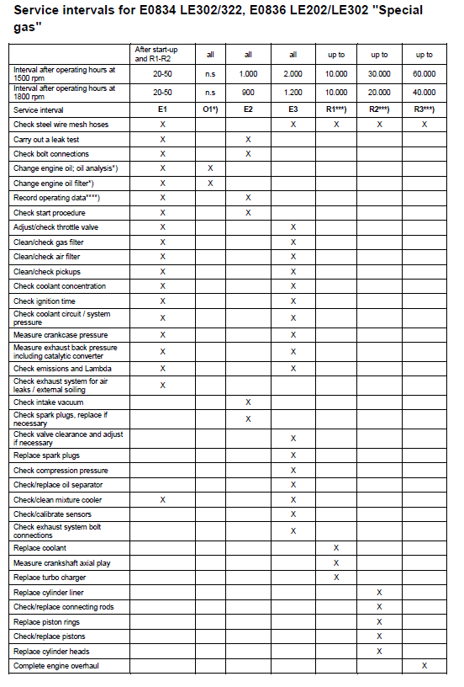

# Declaration of conformity



1. Gesonderte Displays auf Anfrage [↑](#footnote-ref-1)